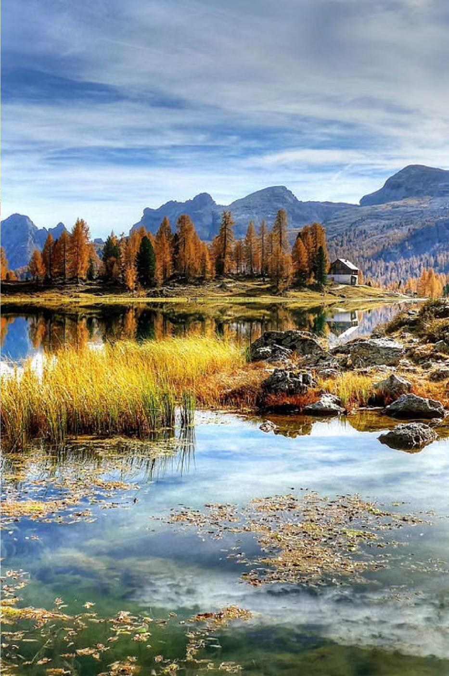







Travel and tourism are key drivers of the global economy, encompassing



personal growth.

# Trends in the Travel Industry

## Rise of Experiential Travel



Travelers seek immersive, authentic

experiences that allow them to engage with local cultures and environments. This trend drives the growth of activities like culinary tours, adventure sports, and cultural

immersion programs.

## Digital Nomadism

The rise of remote work empowers people to travel and work from anywhere, fueling the growth of digital nomad communities and co-living/co-working spaces in popular destinations.

## Personalized Experiences

Travelers seek highly customized itineraries and services that cater to their unique interests and preferences. AI-powered trip planning and

## Sustainable Tourism

Eco-conscious travelers prioritize businesses and destinations that promote

environmental conservation, support local economies, and reduce their carbon footprint. This has led to a surge in

sustainable hospitality and tour offerings. hyper-personalized recommendations are becoming more prevalent.

**Sustainable Tourism Practices**

### Ecotourism Cultural Preservation

Ecotourism focuses on responsible travel to natural areas, conserving the environment and improving the well-being of local

communities.

Sustainable tourism respects and preserves the cultural heritage of destinations, ensuring that local customs and traditions are honored.

### Waste Reduction Local Engagement

Sustainable tourism minimizes waste and promotes recycling and proper waste disposal to reduce the environmental impact of travel.

Sustainable tourism involves and empowers local communities, providing economic opportunities and a voice in tourism development.



  



unique, off-the-beaten-path experiences, these



# The Impact of Technology on



Travel

## Digital Seamless Immersive Data-Driven Disruption Connectivity Experiences Insights

The rise of online Widespread internet Virtual and Big data and booking platforms, access, 5G networks, augmented reality analytics help travel mobile apps, and AI- and smart devices technologies offer providers personalize powered travel enable travelers to new ways for

offerings, optimize assistants has stay connected, travelers to explore operations, and transformed the way share experiences, destinations, preview deliver more tailored we plan and and access real-time accommodations, experiences to meet

experience travel, information on the and enhance their the evolving needs of making it more go. overall travel travelers. convenient and experiences. personalized.

# Ecotourism and Adventure Travel

## Immersive Ecotourism

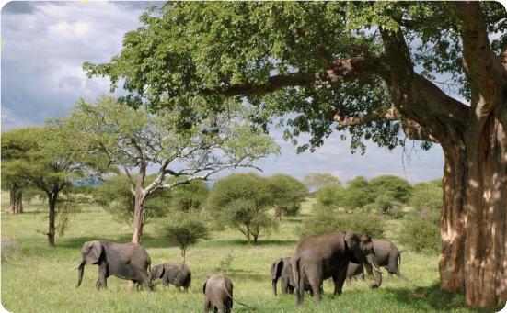

Ecotourism offers

transformative experiences that connect travelers with the natural world. From guided

hikes through pristine

rainforests to snorkeling in vibrant coral reefs, ecotourism promotes sustainability and environmental stewardship.

## Adrenaline-Fueled Adventures

Adventure travel beckons

thrillseekers to explore remote destinations through activities

like rock climbing, white-water rafting, and mountain trekking. These immersive experiences cultivate a deep appreciation

for the power and beauty of the great outdoors.

## Responsible Wildlife Encounters

Ecotourism providers offer guided wildlife viewing

experiences that prioritize the well-being of animals. Travelers can observe majestic creatures in their natural habitats while supporting conservation efforts and minimizing human impact.





  





interactive experiences and

hands-on activities. destination.

# Hospitality and Accommodation



Innovations

## Sustainable Smart Rooms Wellness Unique Design Amenities Experiences

Voice-controlled

Hotels are embracing lighting, In-room fitness Boutique hotels and eco-friendly temperature, and equipment, vacation rentals offer architecture and entertainment meditation spaces, immersive cultural renewable energy to systems allow guests and healthy dining experiences,

from reduce their to personalize their options cater to cooking classes to environmental stay.

Integrated apps travelers prioritizing guided local tours. impact. Features like provide seamless

self-care. Spas and Guests can connect solar panels, water check-in, room wellness retreats with the destination recycling, and locally- service, and offer rejuvenating in a more authentic sourced materials concierge services at treatments to help way. create a greener their

fingertips. guests unwind. guest experience.

**Travel Marketing and Branding Strategies**

t;:J 0 *[eJ*

### Targeted Social Media Authentic Influencer Advertising Presence Storytelling Partnerships

Leveraging data and Building an engaging Crafting immersive Collaborating with

social media brand to narratives that respected travel

|  |  |  |
| --- | --- | --- |
| analytics | to deliver | |
| personalized | | ads th |
| resonate | with spec | |

at connect with potential showcase the unique influencers to reach

ific

travelers and foster

experiences and local

new audiences and

traveler segments. loyalty. cultures of

destinations.

boost brand credibility.

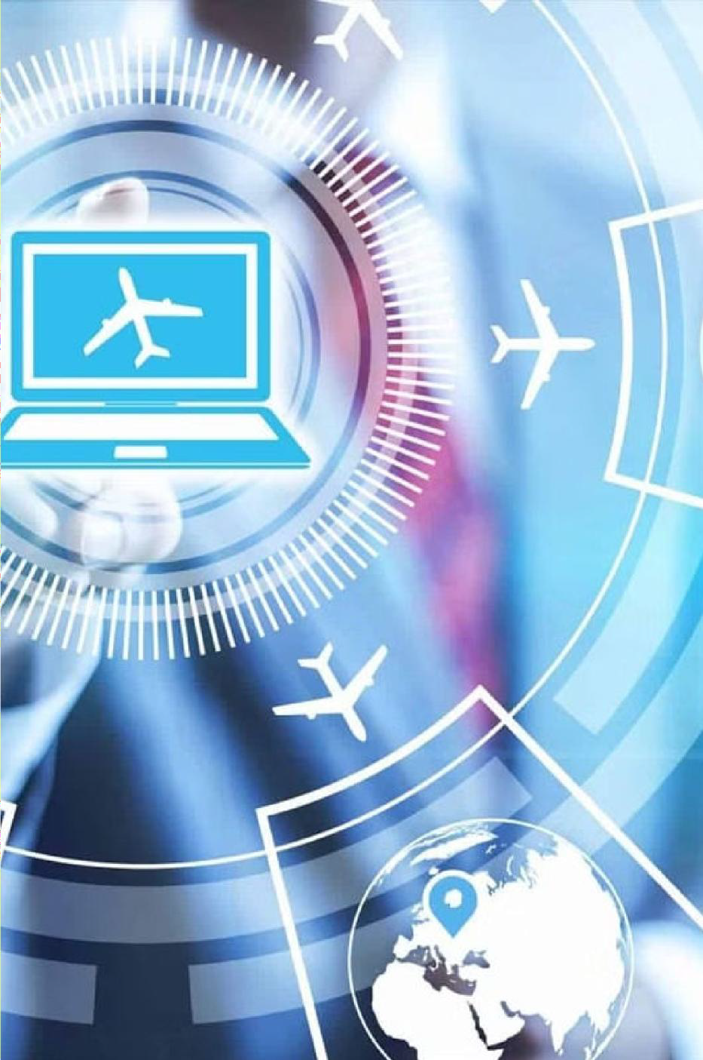









future of travel marked by personalized experiences, seamless mobility,



accommodations, AI-powered trip planning, and enhanced traveler

